Career and Technical Education (CTE) is helping our nation address key challenges such as workforce development, student achievement, economic vitality and global competitiveness.

70 Active Educators Rising Chapters
in Arizona

Career and Technical Student Organizations (CTSOs) are key components to strong CTE programs. CTSOs integrate into CTE programs by extending teaching and learning through innovative programs, business and community partnerships and leadership experiences at the school, state and national levels.

CTSOs provide relevant, engaging programs that improve student achievement, reduce dropout rates and help students discover the wide range of career options available.

CTSOs engage the community and local businesses to help students understand global competition and chart effective and efficient pathways through high school and postsecondary education for their personal success.
DID YOU KNOW?

CTE programs are supported at the federal level by the Carl D. Perkins Career and Technical Education Improvement Act, which provides approximately $1.2 billion dollars in state grants annually to serve more than 14 million students nationwide.

- CTSO programs, such as industry based competitive events and community service, provide students with the opportunity to develop 21st century skills focused on creativity, problem solving, teamwork and goal setting.
- CTSOs bring relevance to the classroom and prepare students to be college and career ready.

Making an Impact

Visit us at
www.edrisingaz.org

Follow us on social media.

Educators Rising Arizona

@EdRisingAZ

Students who participate in CTSOs demonstrate higher levels of academic engagement and motivation, civic engagement, career self-efficacy and employability skills than other students.

According to the National Research Center for Career and Technical Education, participating in leadership and professional development activities in a CTSO raises students’ educational aspirations.
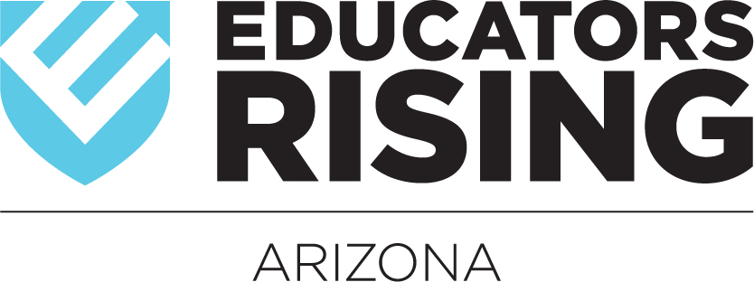

Students who participate in school organizations in 10th grade have higher grade point averages and are more likely to be enrolled in college at age 21 than other students.

