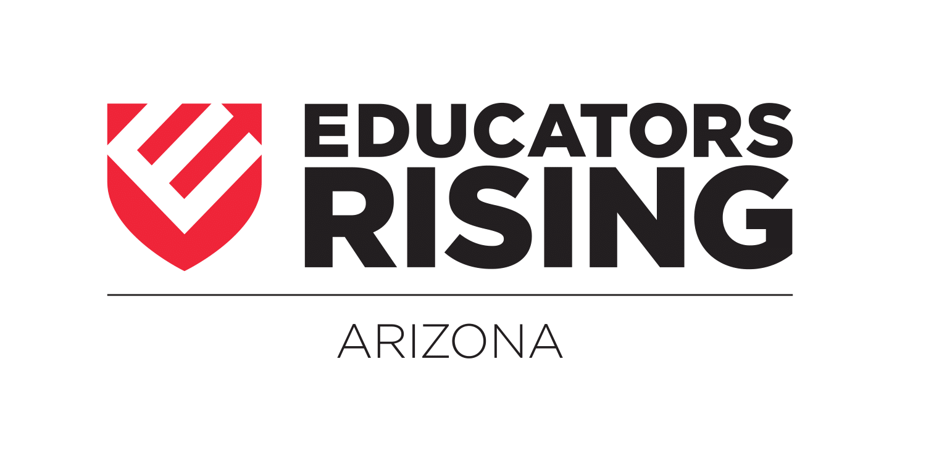
2019-2020 Calendar of Events*#
May 2-4, 2019: State Officer Orientation and Training – Phoenix, AZ
June 2-6, 2019: State Officer Leadership Training – Phoenix, AZ
August 1-3, 2019: State Officer Public Speaking and Chapter Visit Training - Phoenix, AZ
September 1, 2019: Literacy Lives Registration Opens
September 13, 2019: Train the Trainer for CPR @ADE on Central Ave – Phoenix, AZ
September 15, 2019: Literacy Lives Registration Closes
September 20, 2019: Fall Leadership Conference Registration Opens on the EdRising AZ website
September 27, 2019: Literacy Lives Statewide Charity Event Kick Off @Chase Field - Phoenix, AZ
September 30, 2019: Chapter Registration Due – This must be done by EVERY active chapter annually.
October 4, 2019: Fall Leadership Conference Registration Closes
October 11, 2019: FLC Prep for State Officers @ADE on Central Ave – Phoenix, AZ
October 22, 2019: Fall Leadership Conference at ASU – Tempe, AZ
October 24, 2019: AEF Teacher of the Year Luncheon for State Officers – Phoenix, AZ
January 6, 2020: State Officer Application opens
January 13, 2020: State Leadership Conference Registration Opens
January 24, 2020: State Leadership Conference Registration Closes
January 31, 2020: State Leadership Conference Required Competitive Events Materials to be Uploaded Due
January 31, 2020: Literacy Lives Statewide Charity Event Ends
January 31, 2020: State Officer Applications due
February 12, 2020: 2020-2021 State Officer Interviews @ ADE on Central Ave
February 14, 2020: SLC Prep for State Officers @ADE on Central Ave – Phoenix, AZ
March 2-4, 2020: State Leadership Conference Westward Look - Tucson, AZ
June 2020: National Leadership Conference Location and dates TBD
*dates/locations may subject to change – full, up-to-date information can be found at www.edrisingaz.org
#Registration for all events can be found at www.edrisingaz.org

