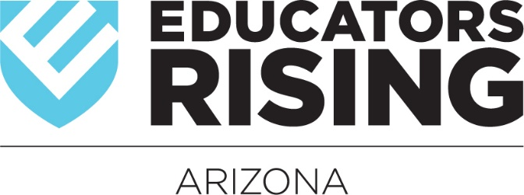

2020 - 2021 Calendar of Events*#
May 6 – 9, 2020: State Officer Orientation and Leadership Training – Phoenix, AZ
May 31 – June 5, 2020: State Officer Leadership Training – Phoenix, AZ
August 5 – 8, 2020: State Officer Public Speaking and Chapter Visit Training - Phoenix, AZ
September 14, 2020: Literacy Lives Registration Opens
September 18, 2020: Literacy Lives Registration Closes
September 25, 2020: Literacy Lives Statewide Charity Event Kick Off @ Phoenix College - Phoenix, AZ
September 30, 2020: Chapter Registration Due – This must be done by EVERY active chapter annually.
October 12, 2020: Fall Leadership Conference Registration Opens
October 16, 2020: Fall Leadership Conference Registration Closes
October 23, 2020: FLC Prep for State Officers @ADE on Central Ave – Phoenix, AZ
October 23, 2020: AEF Teacher of the Year Dinner – Phoenix, AZ
October 27, 2020: Fall Leadership Conference @ ASU Tempe – Tempe, AZ
January 25, 2021: State Officer Applications open
January 31, 2021: Literacy Lives Statewide Charity Event Ends
February 5, 2021: State Officer Applications due
February 15, 2021: State Leadership Conference Registration opens
February 17, 2021: State Officer Interviews @ ADE on Central Ave
February 26, 2021: State Leadership Conference Registration Closes
March 5, 2021: State Leadership Conference Required Competitive Events Materials to be Uploaded Due
March 19, 2021: SLC Prep for State Officers @ADE on Central Ave – Phoenix, AZ
March 29 - 31, 2021: State Leadership Conference @ El Conquistador - Tucson, AZ
June 2021: National Leadership Conference - Location and dates TBD
*dates/locations may subject to change – full, up-to-date information can be found at www.edrisingaz.org
#Registration for all events can be found at www.edrisingaz.org

