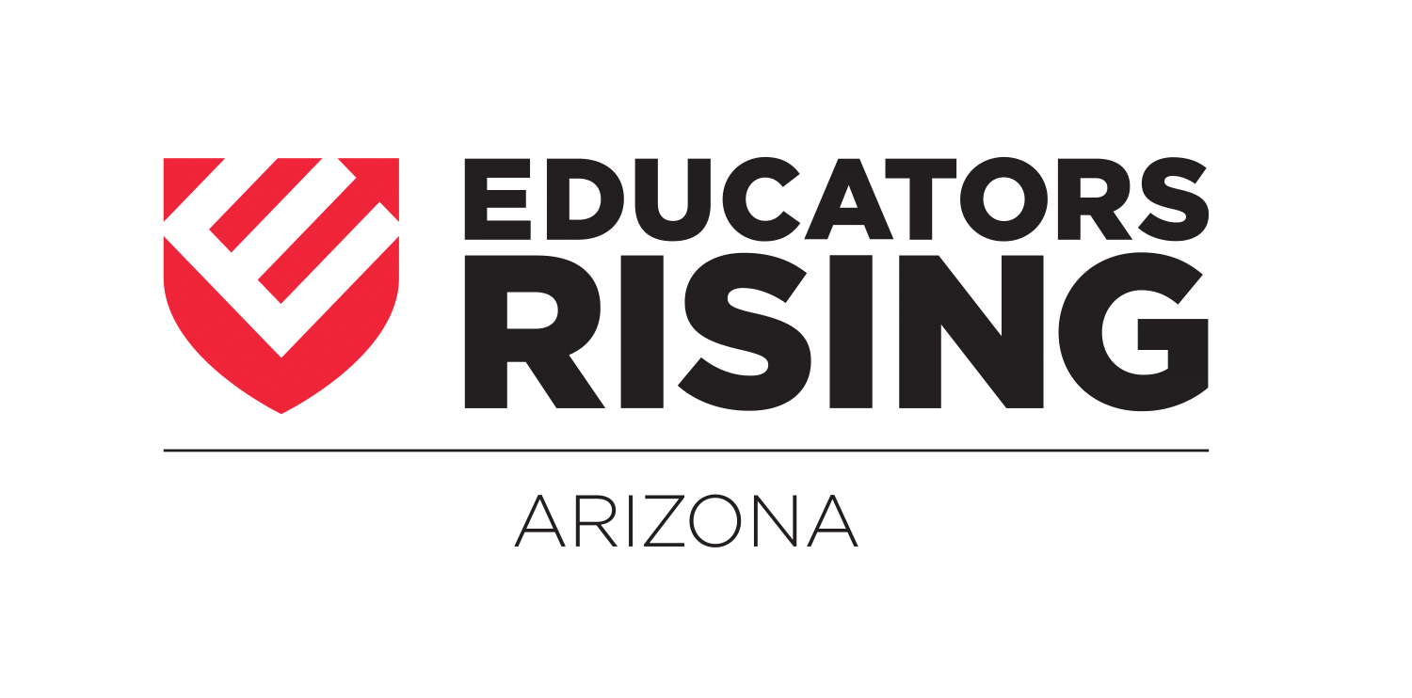

ADVISOR ASSURANCE FORM
EdRising ARIZONA STATEMENT OF ASSURANCE
(Complete this form and upload with your bylaws and program of work when you have collected comprehensive consent forms from all members)

School: Advisor: Date:

- - - - - - - - - - - - - - - - - - - - - - - - - - - - - - - - - - - - - - - - - - - - - - - - - - - - - - - - - - -
I have properly completed and signed the Educators Rising
Arizona Comprehensive Consent Form for each student attending any of the following Educators Rising sponsored activities, workshops, conferences, camps or trainings:

EdRising Chapter Officer Training - EdRising Leadership Camp - EdRising Arizona State Conference & Competitions- All EdRising Sponsored Events

By signing below I am also indicating that I have the Educators Rising Arizona Comprehensive Consent Form in my possession for the duration of any of the above activities, including travel to and from the activity. I also understand the following:

1 Educators Rising Arizona will NOT collect the Comprehensive Consent Forms prior to or at Arizona EdRising activities. The teacher leader will keep these. (The EdRising Arizona Director will only collect this Advisor Assurance Form stating you have completed a Comprehensive Consent Form for every student attending an event.)
- All advisors must take the EdRising Arizona Comprehensive Consent Form with them to each event.
- The EdRising Arizona Comprehensive Consent Form, when properly and totally completed, represents my student’s and my best liability and medical protection during EdRising Arizona events and activities.
- The paper work will be completed in my district that will meet the specific guidelines of the district prior to attending any EdRising Arizona sponsored event.

5 I have read the above and hereby offer assurances that I understand and agree to comply with and enforce the policies stated as indicated by my signature appearing below.

DATE |  | CHAPTER ADVISOR SIGNATURE
SCHOOL |  | CHAPTER ADVISOR’S NAME PRINTED/TYPED

