Up to $1,000 in Scholarship Awards Available
to Educators Rising Arizona State Leadership Conference
Competition Winners

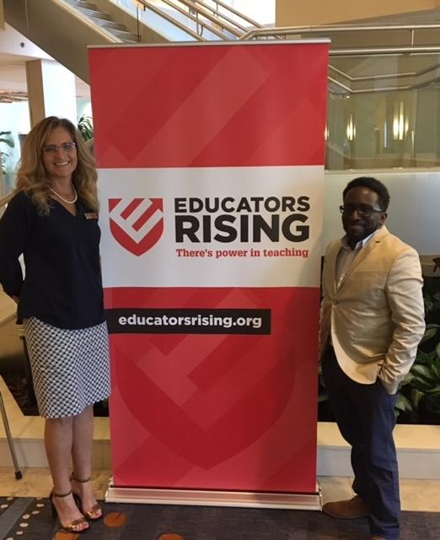
Educators Rising Scholarships will be awarded to attend Rio Salado College for 2nd place winners in the following competitions:

- Educators Rising Moment $500.00
- ECE: Language & Literacy $500.00

Who is eligible?

- Must be a current junior or senior in high school
- Must win 2nd place in one of the above listed competitions at the State Leadership Conference
- Winners must use the funds to pursue coursework from Rio Salado College (including Dual Enrollment)
- All applicants must be able to meet enrollment requirements for the Maricopa
Community College system as well as the
admission requirements for Rio Salado College

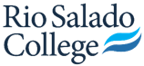
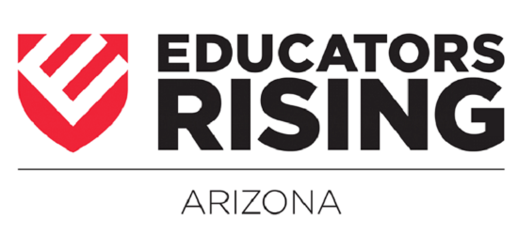
For additional questions, please contact Kim Tobey at kimberly.tobey@riosalado.edu

